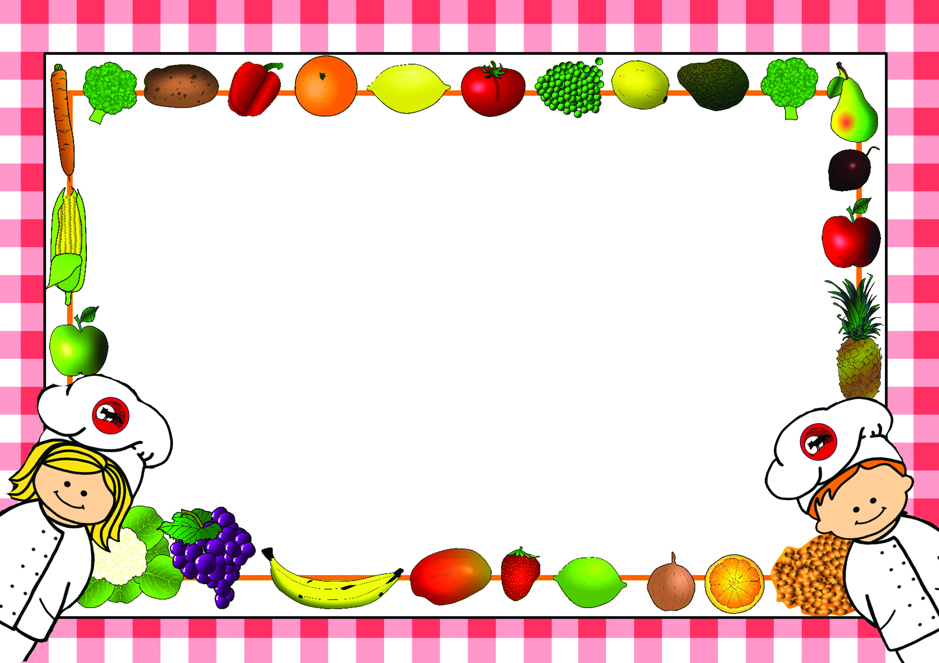

*Menus are correct at time of printing however menus may need to change occasionally
if products are unavailable or on ‘Themed Days’ which will be notified in advance*

Lunch Menus – Spring Term 1
2024-2025

Name of Child……………………………………………………………Class……………………………
□Please tick this box if you do not want your child to make any changes to the choices in the menu.

For office use:
Date received……………………… Returned to Parent………………………

Lunch Menu – Spring Term 1 - Week 1
Monday 6th January 2025

Week - | Monday | Tick | Tuesday | Tick | Wednesday | Tick | Thursday | Tick | Friday | Tick
Example | Sausage
Main Course | Savoury Mince |  | Fish Goujons |  | Roast Chicken |  | Pasta with Homemade Tomato Sauce & Cheese |  | Hot Dogs
Vegetarian  Option | Vegetable Savoury Mince |  |  |  | Quorn |  |  |  | Veggie Dogs
Light Bite | Beans on Toast |  | Cheese Panini |  | Cheese & Onion Quiche |  | Pasta with Cheese |  | Tuna Mayo Wrap
Jacket Potato  (Please circle topping choice) | Cheese, Beans  Tuna |  | Cheese, Beans  Tuna |  | Cheese, Beans  Tuna |  | Cheese, Beans  Tuna |  | Cheese, Beans  Tuna
Sandwich  Please tick your choice of sandwich | Ham |  | Ham |  | Ham |  | Ham |  | Ham
Sandwich  Please tick your choice of sandwich | Cheese |  | Cheese |  | Cheese |  | Cheese |  | Cheese
Sandwich  Please tick your choice of sandwich | Egg |  | Egg |  | Egg |  | Egg |  | Egg
Sandwich  Please tick your choice of sandwich | Tuna |  | Tuna |  | Tuna |  | Tuna |  | Tuna
Carbohydrate | Yorkshire Pudding  Mashed Potato |  | Boiled Potatoes |  | Roast Potatoes  Yorkshire Pudding |  | Pasta |  | Potato Wedges
Vegetables/  Accompaniments | Sweetcorn |  | Peas  Beans |  | Green Cabbage  Dice Carrots |  | Garlic Bread |  | Peas  Beans
Desserts | Treacle Sponge with Custard |  | Flapjack |  | Iced Ginger Sponge |  | Pear & Chocolate Crumble with Custard |  | Arctic Roll
All meals are cooked from scratch on a daily basis. Carbohydrates, Vegetables and Desserts can be chosen on the day so no need to pre-order. Please indicate by ticking what your child would like for Main Course as shown in the example and return to school. Meals are at a cost of £2.35 a day and can be paid on Parent-Pay or in cash or cheque to school. No payment is required from Reception or KS.1

Lunch Menu – Spring Term 1 - Week 2
Monday 13th January 2025

Week - | Monday | Tick | Tuesday | Tick | Wednesday | Tick | Thursday | Tick | Friday | Tick
Main Course | Chicken Pie |  | Homemade Burgers |  | Sausage |  | Katsu Chicken Strips |  | Fish Fingers
Vegetarian  Option | Cheese & Onion Pie |  | Veggie Burgers |  | Quorn Sausage |  | Vegetable Katsu |  | Veggie Fingers
Light Bite | Pasta with Cheese |  | Beans on Toast |  | Sausage Sandwich |  | Cheese Panini |  | Fish Finger Sandwich
Jacket Potato  (Please circle topping choice) | Cheese, Beans  Tuna |  | Cheese, Beans  Tuna |  | Cheese, Beans  Tuna |  | Cheese, Beans  Tuna |  | Cheese, Beans  Tuna
Sandwich  Please tick your choice of sandwich | Ham |  | Ham |  | Ham |  | Ham |  | Ham
Sandwich  Please tick your choice of sandwich | Cheese |  | Cheese |  | Cheese |  | Cheese |  | Cheese
Sandwich  Please tick your choice of sandwich | Egg |  | Egg |  | Egg |  | Egg |  | Egg
Sandwich  Please tick your choice of sandwich | Tuna |  | Tuna |  | Tuna |  | Tuna |  | Tuna
Carbohydrate | Sauté Potatoes |  | Oven Chips |  | Mashed Potato |  | Savoury Rice |  | Oven Chips
Vegetables/  Accompaniments | Green Cabbage |  | Coleslaw  Salad |  | Mixed Peas & Carrots |  | Mixed Green Salad |  | Peas  Beans
Desserts | Oat Biscuit |  | Carrot Cake |  | Chocolate Sponge & Chocolate Sauce |  | Rice Pudding with Jam or Sultanas |  | Jelly
All meals are cooked from scratch on a daily basis. Carbohydrates, Vegetables and Desserts can be chosen on the day so no need to pre-order. Please indicate by ticking what your child would like for Main Course as shown in the example and return to school. Meals are at a cost of £2.35 a day and can be paid on Parent-Pay or in cash or cheque to school. No payment is required from Reception or KS.1

Lunch Menu – Spring Term 1 - Week 3
Monday 20th January 2025

Week - | Monday | Tick | Tuesday | Tick | Wednesday | Tick | Thursday | Tick | Friday | Tick
Main Course | Spaghetti Bolognaise |  | Chicken Korma |  | Brunch |  | Roast Gammon |  | Cheese & Tomato Pizza
Vegetarian  Option | Quorn Bolognaise |  | Vegetable Korma |  | Veggie Brunch |  | Quorn
Light Bite | Pasta with Cheese |  | Beans on Toast |  | Tomato & Red Pepper Soup |  | Spaghetti Hoops on Toast |  | Vegetable Ravioli
Jacket Potato  (Please circle topping choice) | Cheese, Beans  Tuna |  | Cheese, Beans  Tuna |  | Cheese, Beans  Tuna |  | Cheese, Beans  Tuna |  | Cheese, Beans  Tuna
Sandwich  Please tick your choice of sandwich | Ham |  | Ham |  | Ham |  | Ham |  | Ham
Sandwich  Please tick your choice of sandwich | Cheese |  | Cheese |  | Cheese |  | Cheese |  | Cheese
Sandwich  Please tick your choice of sandwich | Egg |  | Egg |  | Egg |  | Egg |  | Egg
Sandwich  Please tick your choice of sandwich | Tuna |  | Tuna |  | Tuna |  | Tuna |  | Tuna
Carbohydrate | Pasta |  | Savoury Rice |  | Hash Browns  Toast |  | Roast Potatoes |  | Oven Chips
Vegetables/  Accompaniments | Finger Vegetables |  | Naan Bread |  | Beans |  | Carrots  Cabbage |  | Peas
Desserts | Jam Sponge & Custard |  | Berries & Natural Yoghurt |  | Chocolate Brownie |  | Syrup Sponge with Custard |  | Fruit Mousse
All meals are cooked from scratch on a daily basis. Carbohydrates, Vegetables and Desserts can be chosen on the day so no need to pre-order. Please indicate by ticking what your child would like for Main Course as shown in the example and return to school. Meals are at a cost of £2.35 a day and can be paid on Parent-Pay or in cash or cheque to school. No payment is required from Reception or KS.1

Lunch Menu – Spring Term 1 - Week 4
Monday 27th January 2025

Week - | Monday | Tick | Tuesday | Tick | Wednesday | Tick | Thursday | Tick | Friday | Tick
Main Course | Savoury Mince |  | Fish Goujons |  | Roast Chicken |  | Pasta with Homemade Tomato Sauce & Cheese |  | Hot Dogs
Vegetarian  Option | Vegetable Savoury Mince |  |  |  | Quorn |  |  |  | Veggie Dogs
Light Bite | Beans on Toast |  | Cheese Panini |  | Cheese & Onion Quiche |  | Pasta with Cheese |  | Tuna Mayo Wrap
Jacket Potato  (Please circle topping choice) | Cheese, Beans  Tuna |  | Cheese, Beans  Tuna |  | Cheese, Beans  Tuna |  | Cheese, Beans  Tuna |  | Cheese, Beans  Tuna
Sandwich  Please tick your choice of sandwich | Ham |  | Ham |  | Ham |  | Ham |  | Ham
Sandwich  Please tick your choice of sandwich | Cheese |  | Cheese |  | Cheese |  | Cheese |  | Cheese
Sandwich  Please tick your choice of sandwich | Egg |  | Egg |  | Egg |  | Egg |  | Egg
Sandwich  Please tick your choice of sandwich | Tuna |  | Tuna |  | Tuna |  | Tuna |  | Tuna
Carbohydrate | Yorkshire Pudding  Mashed Potato |  | Boiled Potatoes |  | Roast Potatoes  Yorkshire Pudding |  | Pasta |  | Potato Wedges
Vegetables/  Accompaniments | Sweetcorn |  | Peas  Beans |  | Green Cabbage  Dice Carrots |  | Garlic Bread |  | Peas  Beans
Desserts | Treacle Sponge with Custard |  | Flapjack |  | Iced Ginger Sponge |  | Pear & Chocolate Crumble with Custard |  | Arctic Roll
All meals are cooked from scratch on a daily basis. Carbohydrates, Vegetables and Desserts can be chosen on the day so no need to pre-order. Please indicate by ticking what your child would like for Main Course as shown in the example and return to school. Meals are at a cost of £2.35 a day and can be paid on Parent-Pay or in cash or cheque to school. No payment is required from Reception or KS.1

Lunch Menu – Spring Term 1 - Week 5
Monday 3rd February 2025

Week - | Monday | Tick | Tuesday | Tick | Wednesday | Tick | Thursday | Tick | Friday | Tick
Main Course | Chicken Pie |  | Homemade Burgers |  | Sausage |  | Katsu Chicken Strips |  | Fish Fingers
Vegetarian  Option | Cheese & Onion Pie |  | Veggie Burgers |  | Quorn Sausage |  | Vegetable Katsu |  | Veggie Fingers
Light Bite | Pasta with Cheese |  | Beans on Toast |  | Sausage Sandwich |  | Cheese Panini |  | Fish Finger Sandwich
Jacket Potato  (Please circle topping choice) | Cheese, Beans  Tuna |  | Cheese, Beans  Tuna |  | Cheese, Beans  Tuna |  | Cheese, Beans  Tuna |  | Cheese, Beans  Tuna
Sandwich  Please tick your choice of sandwich | Ham |  | Ham |  | Ham |  | Ham |  | Ham
Sandwich  Please tick your choice of sandwich | Cheese |  | Cheese |  | Cheese |  | Cheese |  | Cheese
Sandwich  Please tick your choice of sandwich | Egg |  | Egg |  | Egg |  | Egg |  | Egg
Sandwich  Please tick your choice of sandwich | Tuna |  | Tuna |  | Tuna |  | Tuna |  | Tuna
Carbohydrate | Sauté Potatoes |  | Oven Chips |  | Mashed Potato |  | Savoury Rice |  | Oven Chips
Vegetables/  Accompaniments | Green Cabbage |  | Coleslaw  Salad |  | Mixed Peas & Carrots |  | Mixed Green Salad |  | Peas  Beans
Desserts | Oat Biscuit |  | Carrot Cake |  | Chocolate Sponge & Chocolate Sauce |  | Rice Pudding with Jam or Sultanas |  | Jelly
All meals are cooked from scratch on a daily basis. Carbohydrates, Vegetables and Desserts can be chosen on the day so no need to pre-order. Please indicate by ticking what your child would like for Main Course as shown in the example and return to school. Meals are at a cost of £2.35 a day and can be paid on Parent-Pay or in cash or cheque to school. No payment is required from Reception or KS.1

Lunch Menu – Spring Term 1 - Week 6
Monday 10th February 2025

Week - | Monday | Tick | Tuesday | Tick | Wednesday | Tick | Thursday | Tick | Friday | Tick
Main Course | Spaghetti Bolognaise |  | Chicken Korma |  | Brunch |  | Minced Beef, Pepper & Rice Burritos |  | Cheese & Tomato Pizza
Vegetarian  Option | Quorn Bolognaise |  | Vegetable Korma |  | Veggie Brunch |  | Vegetable Burritos
Light Bite | Pasta with Cheese |  | Beans on Toast |  | Tomato & Red Pepper Soup |  | Spaghetti Hoops on Toast |  | Vegetable Ravioli
Jacket Potato  (Please circle topping choice) | Cheese, Beans  Tuna |  | Cheese, Beans  Tuna |  | Cheese, Beans  Tuna |  | Cheese, Beans  Tuna |  | Cheese, Beans  Tuna
Sandwich  Please tick your choice of sandwich | Ham |  | Ham |  | Ham |  | Ham |  | Ham
Sandwich  Please tick your choice of sandwich | Cheese |  | Cheese |  | Cheese |  | Cheese |  | Cheese
Sandwich  Please tick your choice of sandwich | Egg |  | Egg |  | Egg |  | Egg |  | Egg
Sandwich  Please tick your choice of sandwich | Tuna |  | Tuna |  | Tuna |  | Tuna |  | Tuna
Carbohydrate | Pasta |  | Savoury Rice |  | Hash Browns  Toast |  | Potato Wedges |  | Oven Chips
Vegetables/  Accompaniments | Finger Vegetables |  | Naan Bread |  | Beans |  | Sweet Corn |  | Peas
Desserts | Jam Sponge & Custard |  | Berries & Natural Yoghurt |  | Syrup Sponge with Custard |  | Chocolate Brownies |  | Fruit Mousse
All meals are cooked from scratch on a daily basis. Carbohydrates, Vegetables and Desserts can be chosen on the day so no need to pre-order. Please indicate by ticking what your child would like for Main Course as shown in the example and return to school. Meals are at a cost of £2.35 a day and can be paid on Parent-Pay or in cash or cheque to school. No payment is required from Reception or KS.1

