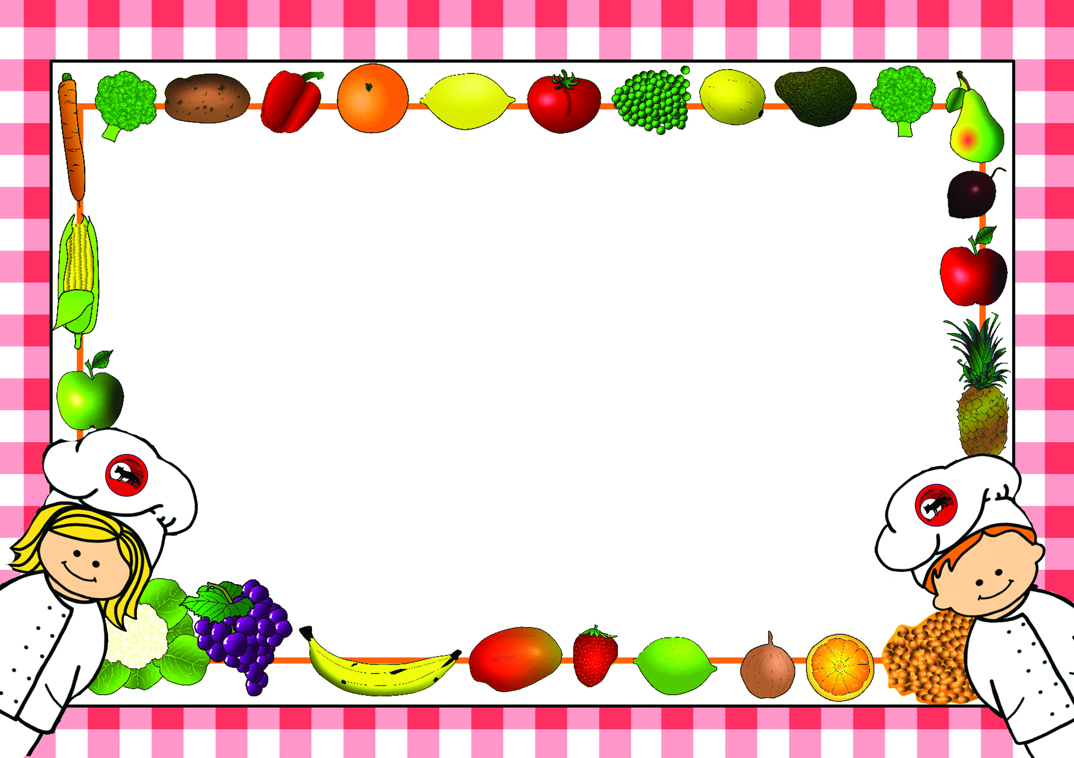

*Menus are correct at time of printing however menus may need to change occasionally
if products are unavailable or on ‘Themed Days’ which will be notified in advance*

Lunch Menus – Autumn Term 2
2024-2025

Name of Child……………………………………………………………Class……………………………
□Please tick this box if you do not want your child to make any changes to the choices in the menu.

For office use:
Date received……………………… Returned to Parent………………………

Lunch Menu – Autumn Term 1 - Week 1
Monday 4th November 2024

Week - | Monday | Tick | Tuesday | Tick | Wednesday | Tick | Thursday | Tick | Friday | Tick
Example | Sausage |  | 
Main Course | Tuna & Pasta Bake in a Tomato Sauce |  | Homemade Sausage Roll |  | Roast Gammon |  | Chicken & Bacon Carbonara |  | Cheese & Tomato Pizza
Vegetarian  Option | Macaroni Cheese |  | Cheese & Onion Roll |  | Cauliflower & Broccoli Cheese |  | Cheese & Onion Quiche |  | Pasta with Cheese
Light Bite | Spaghetti Hoops on Toast |  | Beans on Toast |  | Tomato Soup & Roll |  | Meat Ravioli with Cheese |  | Pasta with Cheese
Jacket Potato  (Please circle topping choice) | Cheese, Beans  Tuna |  | Cheese, Beans  Tuna |  | Cheese, Beans  Tuna |  | Cheese, Beans  Tuna |  | Cheese, Beans  Tuna
Sandwich  Please tick your choice of sandwich | Ham |  | Ham |  | Ham |  | Ham |  | Ham
Sandwich  Please tick your choice of sandwich | Cheese |  | Cheese |  | Cheese |  | Cheese |  | Cheese
Sandwich  Please tick your choice of sandwich | Egg |  | Egg |  | Egg |  | Egg |  | Egg
Sandwich  Please tick your choice of sandwich | Tuna |  | Tuna |  | Tuna |  | Tuna |  | Tuna
Carbohydrate | Pasta |  | Mashed Potatoes |  | Yorkshire Pudding  Roast Potatoes |  | Spaghetti |  | Potato Wedges
Vegetables/  Accompaniments | Crusty Bread |  | Beans |  | Broccoli  Sliced Carrots |  | Crusty Bread |  | Beans  Sweetcorn
Desserts | Chocolate Sponge & Chocolate Sauce |  | Chocolate Apple |  | Chocolate Chip Cookie |  | Sticky Toffee Pudding  with Custard |  | Jelly
All meals are cooked from scratch on a daily basis. Carbohydrates, Vegetables and Desserts can be chosen on the day so no need to pre-order. Please indicate by ticking what your child would like for Main Course as shown in the example and return to school. Meals are at a cost of £2.35 a day and can be paid on Parent-Pay or in cash or cheque to school. No payment is required from Reception or KS.1

Lunch Menu – Autumn Term 2 - Week 2
Monday 11th November 2024

Week - | Monday | Tick | Tuesday | Tick | Wednesday | Tick | Thursday | Tick | Friday | Tick
Main Course | Chicken Tikka Masala |  | Pasta with Homemade Tomato & Vegetable Sauce |  | Sausage |  | Lasagne |  | Fish Fingers
Vegetarian  Option | Vegetable Tikka Masala |  |  |  | Veggie Sausage |  | Veggie Lasagne |  | Veggie Fingers
Light Bite | Cheese Panini |  | Pasta with Cheese |  | Sausage Sandwich |  | Beans on Toast |  | Cheese Savoury Wrap
Jacket Potato  (Please circle topping choice) | Cheese, Beans  Tuna |  | Cheese, Beans  Tuna |  | Cheese, Beans  Tuna |  | Cheese, Beans  Tuna |  | Cheese, Beans  Tuna
Sandwich  Please tick your choice of sandwich | Ham |  | Ham |  | Ham |  | Ham |  | Ham
Sandwich  Please tick your choice of sandwich | Cheese |  | Cheese |  | Cheese |  | Cheese |  | Cheese
Sandwich  Please tick your choice of sandwich | Egg |  | Egg |  | Egg |  | Egg |  | Egg
Sandwich  Please tick your choice of sandwich | Tuna |  | Tuna |  | Tuna |  | Tuna |  | Tuna
Carbohydrate | Savoury Rice |  | Pasta |  | Mashed Potato |  | Pasta |  | Oven Chips
Vegetables/  Accompaniments | Naan |  | Garlic Slice |  | Diced Carrots  Green Cabbage |  | Mixed Salad |  | Beans  Peas
Desserts | Treacle Dumpling with Custard |  | Chocolate Brownie |  | Strawberry Crumble Slice with Custard |  | Iced Lemon Slice |  | Chocolate Krispie Nest
All meals are cooked from scratch on a daily basis. Carbohydrates, Vegetables and Desserts can be chosen on the day so no need to pre-order. Please indicate by ticking what your child would like for Main Course as shown in the example and return to school. Meals are at a cost of £2.35 a day and can be paid on Parent-Pay or in cash or cheque to school. No payment is required from Reception or KS.1

Lunch Menu – Autumn Term 2 - Week 3
Monday 18th November 2024

Week - | Monday | Tick | Tuesday | Tick | Wednesday | Tick | Thursday | Tick | Friday | Tick
Main Course | Crispy Fish Portion |  | Spaghetti Bolognaise |  | Chicken Stew |  | Sticky Chicken Drummers |  | Hot Dogs
Vegetarian  Option |  |  | Veggie Bolognaise |  | Vegetable Stew |  | Cheese & Onion Roll |  | Veggie Dogs
Light Bite | Cheese Panini |  | Pasta with Cheese |  | Beans on Toast |  | Roasted Vegetable & Noodle Bowl |  | Vegetable Ravioli
Jacket Potato  (Please circle topping choice) | Cheese, Beans  Tuna |  | Cheese, Beans  Tuna |  | Cheese, Beans  Tuna |  | Cheese, Beans  Tuna |  | Cheese, Beans  Tuna
Sandwich  Please tick your choice of sandwich | Ham |  | Ham |  | Ham |  | Ham |  | Ham
Sandwich  Please tick your choice of sandwich | Cheese |  | Cheese |  | Cheese |  | Cheese |  | Cheese
Sandwich  Please tick your choice of sandwich | Egg |  | Egg |  | Egg |  | Egg |  | Egg
Sandwich  Please tick your choice of sandwich | Tuna |  | Tuna |  | Tuna |  | Tuna |  | Tuna
Carbohydrate | Boiled Potatoes |  | Pasta |  | Mashed Potato |  | Noodles |  | Oven Chips
Vegetables/  Accompaniments | Peas  Beans |  | Finger Vegetables |  | Yorkshire Pudding |  | Sweetcorn |  | Beans  Peas
Desserts | Rocky Road |  | Flapjack |  | Milk Pudding with Jam or Fruit |  | Caramel Apple Betty with Custard |  | Arctic Roll
All meals are cooked from scratch on a daily basis. Carbohydrates, Vegetables and Desserts can be chosen on the day so no need to pre-order. Please indicate by ticking what your child would like for Main Course as shown in the example and return to school. Meals are at a cost of £2.35 a day and can be paid on Parent-Pay or in cash or cheque to school. No payment is required from Reception or KS.1

Lunch Menu – Autumn Term 2 - Week 4
Monday 25th November 2024

Week - | Monday | Tick | Tuesday | Tick | Wednesday | Tick | Thursday | Tick | Friday | Tick
Main Course | Tuna & Pasta Bake in a Tomato Sauce |  | Minced Beef Hotpot |  | Roast Gammon |  | Chicken & Bacon Carbonara |  | Cheese & Tomato Pizza
Vegetarian  Option | Macaroni Cheese |  | Vegetable Hotpot |  | Cauliflower & Broccoli Cheese |  | Cheese & Onion Quiche |  | Pasta with Cheese
Light Bite | Spaghetti Hoops on Toast |  | Cheese on Toast |  | Tomato Soup & Roll |  | Meat Ravioli with Cheese |  | Pasta with Cheese
Jacket Potato  (Please circle topping choice) | Cheese, Beans  Tuna |  | Cheese, Beans  Tuna |  | Cheese, Beans  Tuna |  | Cheese, Beans  Tuna |  | Cheese, Beans  Tuna
Sandwich  Please tick your choice of sandwich | Ham |  | Ham |  | Ham |  | Ham |  | Ham
Sandwich  Please tick your choice of sandwich | Cheese |  | Cheese |  | Cheese |  | Cheese |  | Cheese
Sandwich  Please tick your choice of sandwich | Egg |  | Egg |  | Egg |  | Egg |  | Egg
Sandwich  Please tick your choice of sandwich | Tuna |  | Tuna |  | Tuna |  | Tuna |  | Tuna
Carbohydrate | Pasta |  | Sliced Potatoes |  | Yorkshire Pudding  Roast Potatoes |  | Spaghetti |  | Potato Wedges
Vegetables/  Accompaniments | Crusty Bread |  | Diced Carrots  Peas  (Mixed) |  | Broccoli  Sliced Carrots |  | Crusty Bread |  | Beans  Sweetcorn
Desserts | Chocolate Sponge & Chocolate Sauce |  | Red Berries with Greek Yoghurt and Honey |  | Sticky Toffee Pudding with Custard |  | Chocolate Chip Cookie |  | Jelly
All meals are cooked from scratch on a daily basis. Carbohydrates, Vegetables and Desserts can be chosen on the day so no need to pre-order. Please indicate by ticking what your child would like for Main Course as shown in the example and return to school. Meals are at a cost of £2.35 a day and can be paid on Parent-Pay or in cash or cheque to school. No payment is required from Reception or KS.1

Lunch Menu – Autumn Term 2 - Week 5
Monday 2nd December 2024

Week - | Monday | Tick | Tuesday | Tick | Wednesday | Tick | Thursday | Tick | Friday | Tick

Concert Rehearsal Day.
Whole School - Picnic Bags
Main Course |  |  | Pasta with Homemade Tomato & Vegetable Sauce |  | Sausage |  | Lasagne |  | Fish Fingers
Vegetarian  Option |  |  |  |  | Veggie Sausage |  | Veggie Lasagne |  | Veggie Fingers
Light Bite |  |  | Pasta with Cheese |  | Sausage Sandwich |  | Beans on Toast |  | Cheese Savoury Wrap
Jacket Potato  (Please circle topping choice) |  |  | Cheese, Beans  Tuna |  | Cheese, Beans  Tuna |  | Cheese, Beans  Tuna |  | Cheese, Beans  Tuna
Sandwich  Please tick your choice of sandwich | Ham |  | Ham |  | Ham |  | Ham |  | Ham
Sandwich  Please tick your choice of sandwich | Cheese |  | Cheese |  | Cheese |  | Cheese |  | Cheese
Sandwich  Please tick your choice of sandwich | Egg |  | Egg |  | Egg |  | Egg |  | Egg
Sandwich  Please tick your choice of sandwich | Tuna |  | Tuna |  | Tuna |  | Tuna |  | Tuna
Carbohydrate |  |  | Pasta |  | Mashed Potato |  | Pasta |  | Oven Chips
Vegetables/  Accompaniments |  |  | Garlic Slice |  | Diced Carrots  Green Cabbage |  | Mixed Salad |  | Beans  Peas
Desserts |  |  | Chocolate Brownie |  | Strawberry Crumble Slice with Custard |  | Iced Lemon Slice |  | Chocolate Krispie Nest
All meals are cooked from scratch on a daily basis. Carbohydrates, Vegetables and Desserts can be chosen on the day so no need to pre-order. Please indicate by ticking what your child would like for Main Course as shown in the example and return to school. Meals are at a cost of £2.35 a day and can be paid on Parent-Pay or in cash or cheque to school. No payment is required from Reception or KS.1

Lunch Menu – Autumn Term 2 - Week 6
Monday 9th December 2024

Week - | Monday | Tick | Tuesday | Tick | Wednesday | Tick | Thursday | Tick | Friday | Tick
 |  |  |  |  | 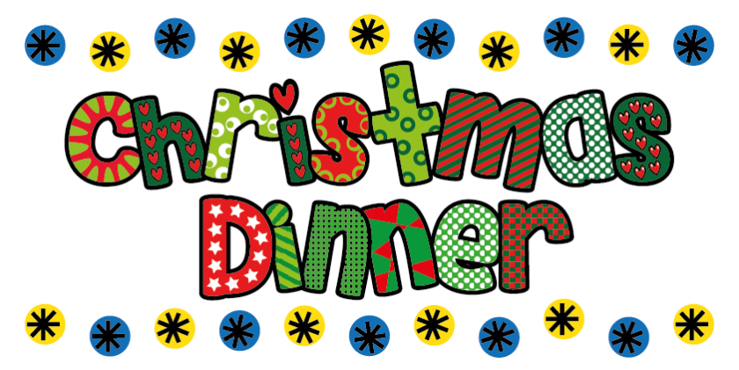
Main Course | Crispy Fish Portion |  | Spaghetti Bolognaise |  | Roast Turkey  Pigs in Blankets  Seasoning |  | Sticky Chicken Drummers |  | Hot Dogs
Vegetarian  Option |  |  | Veggie Bolognaise |  | Vegetable Roll |  | Cheese & Onion Roll |  | Veggie Dogs
Light Bite | Cheese Panini |  | Pasta with Cheese |  |  |  | Roasted Vegetable & Noodle Bowl |  | Vegetable Ravioli
Jacket Potato  (Please circle topping choice) | Cheese, Beans  Tuna |  | Cheese, Beans  Tuna |  |  |  | Cheese, Beans  Tuna |  | Cheese, Beans  Tuna
Sandwich  Please tick your choice of sandwich | Ham |  | Ham |  | Ham |  | Ham |  | Ham
Sandwich  Please tick your choice of sandwich | Cheese |  | Cheese |  | Cheese |  | Cheese |  | Cheese
Sandwich  Please tick your choice of sandwich | Egg |  | Egg |  | Egg |  | Egg |  | Egg
Sandwich  Please tick your choice of sandwich | Tuna |  | Tuna |  | Tuna |  | Tuna |  | Tuna
Carbohydrate | Boiled Potatoes |  | Pasta |  | Mashed Potato  Roast Potato |  | Noodles |  | Oven Chips
Vegetables/  Accompaniments | Peas  Beans |  | Finger Vegetables |  | Buttered Carrots  Brussel Sprouts  Peas |  | Sweetcorn |  | Beans  Peas
Desserts | Rocky Road |  | Flapjack |  | Chocolate Roll |  | Caramel Apple Betty with Custard |  | Arctic Roll
All meals are cooked from scratch on a daily basis. Carbohydrates, Vegetables and Desserts can be chosen on the day so no need to pre-order. Please indicate by ticking what your child would like for Main Course as shown in the example and return to school. Meals are at a cost of £2.35 a day and can be paid on Parent-Pay or in cash or cheque to school. No payment is required from Reception or KS.1

Lunch Menu – Autumn Term 2 - Week 7
Monday 16th December 2024

Week - | Monday | Tick | Tuesday | Tick | Wednesday | Tick | Thursday | Tick | Friday | Tick
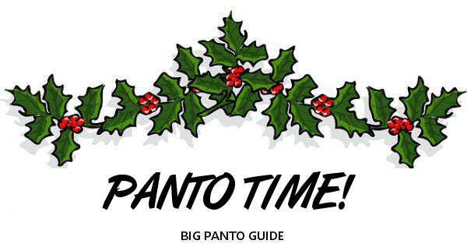
Whole School - Picnic Bags
Main Course | Tuna & Pasta Bake in a Tomato Sauce |  | Minced Beef Hotpot |  |  |  | Chicken & Bacon Carbonara |  | Cheese & Tomato Pizza
Vegetarian  Option | Macaroni Cheese |  | Vegetable Hotpot |  |  |  | Cheese & Onion Quiche
Light Bite | Spaghetti Hoops on Toast |  | Cheese on Toast |  |  |  | Meat Ravioli with Cheese |  | Pasta with Cheese
Jacket Potato  (Please circle topping choice) | Cheese, Beans  Tuna |  | Cheese, Beans  Tuna |  |  |  | Cheese, Beans  Tuna |  | Cheese, Beans  Tuna
Sandwich  Please tick your choice of sandwich | Ham |  | Ham |  | Ham |  | Ham |  | Ham
Sandwich  Please tick your choice of sandwich | Cheese |  | Cheese |  | Cheese |  | Cheese |  | Cheese
Sandwich  Please tick your choice of sandwich | Egg |  | Egg |  | Egg |  | Egg |  | Egg
Sandwich  Please tick your choice of sandwich | Tuna |  | Tuna |  | Tuna |  | Tuna |  | Tuna
Carbohydrate | Pasta |  | Sliced Potatoes |  |  |  | Spaghetti |  | Potato Wedges
Vegetables/  Accompaniments | Crusty Bread |  | Diced Carrots  Peas  (Mixed) |  |  |  | Crusty Bread |  | Beans  Sweetcorn
Desserts | Chocolate Sponge & Chocolate Sauce |  | Red Berries with Greek Yoghurt and Honey |  |  |  | Chocolate Chip Cookie |  | Jelly
All meals are cooked from scratch on a daily basis. Carbohydrates, Vegetables and Desserts can be chosen on the day so no need to pre-order. Please indicate by ticking what your child would like for Main Course as shown in the example and return to school. Meals are at a cost of £2.35 a day and can be paid on Parent-Pay or in cash or cheque to school. No payment is required from Reception or KS.1

