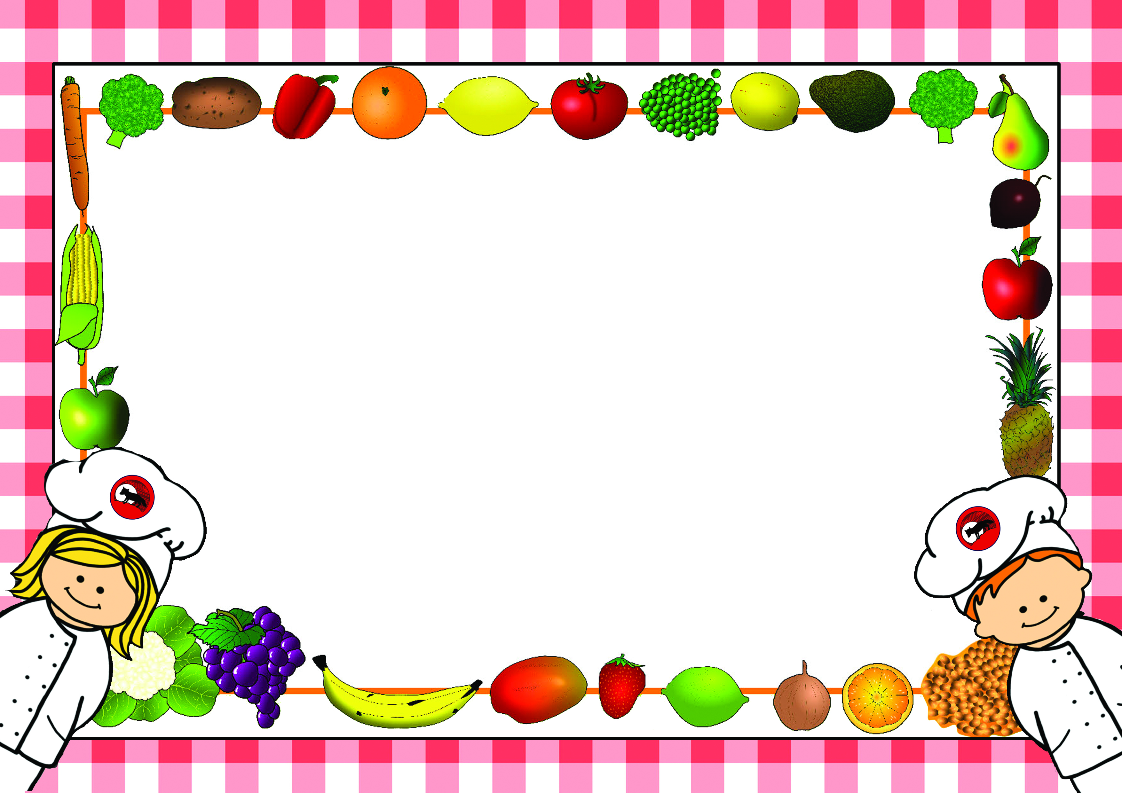

*Menus are correct at time of printing however menus may need to change occasionally
if products are unavailable or on ‘Themed Days’ which will be notified in advance*

Lunch Menus – Autumn Term 1
2024-2025

Name of Child……………………………………………………………Class……………………………
□Please tick this box if you do not want your child to make any changes to the choices in the menu.

For office use:
Date received……………………… Returned to Parent………………………

Lunch Menu – Autumn Term 1 - Week 1
Monday 2nd September 2024

Week - | Monday | Tick | Tuesday | Tick | Wednesday | Tick | Thursday | Tick | Friday | Tick
Example |  |  |  |  | Sausage
Main Course |  |  |  |  | Roast Chicken |  | Spaghetti Bolognaise |  | Fish Fingers
Vegetarian  Option |  |  |  |  | Cauliflower & Broccoli Bake |  | Quorn Mince Bolognaise |  | Vegetable Fingers
Light Bite |  |  |  |  | Tomato & Red Pepper Soup & Roll |  | Pasta with Cheese |  | Fish Finger Sandwiches
Jacket Potato  (Please circle topping choice) |  |  |  |  | Cheese, Beans  Tuna |  | Cheese, Beans  Tuna |  | Cheese, Beans  Tuna
Sandwich  Please tick your choice of sandwich |  |  |  |  | Ham |  | Ham |  | Ham
Sandwich  Please tick your choice of sandwich |  |  |  |  | Cheese |  | Cheese |  | Cheese
Sandwich  Please tick your choice of sandwich |  |  |  |  | Egg |  | Egg |  | Egg
Sandwich  Please tick your choice of sandwich |  |  |  |  | Tuna |  | Tuna |  | Tuna
Carbohydrate |  |  |  |  | Mashed Potato  Yorkshire Pudding |  | Pasta |  | Oven Chips
Vegetables/  Accompaniments |  |  |  |  | Diced Carrots  Green Beans |  | Mixed Salad |  | Peas  Beans
Desserts |  |  |  |  | Chocolate Chip Sponge & Custard |  | Jam Pasty with Custard |  | Chocolate Krispy Nest
All meals are cooked from scratch on a daily basis. Carbohydrates, Vegetables and Desserts can be chosen on the day so no need to pre-order. Please indicate by ticking what your child would like for Main Course as shown in the example and return to school. Meals are at a cost of £2.35 a day and can be paid on Parent-Pay or in cash or cheque to school. No payment is required from Reception or KS.1

Lunch Menu – Autumn Term 1 - Week 2
Monday 9th September 2024

Week - | Monday | Tick | Tuesday | Tick | Wednesday | Tick | Thursday | Tick | Friday | Tick
Main Course | Fish Nuggets |  | Cottage Pie |  | Chicken & Roast Vegetable Tray Bake |  | Pasta with Homemade Tomato Sauce |  | Hot Dog
Vegetarian  Option | Cheese Panini |  | Vegetable Cottage Pie |  | Roasted Vegetable Tray Bake |  |  |  | Veggie Hot Dogs
Light Bite |  |  | Cheese on Toast |  | Beans on Toast |  | Pasta with Cheese |  | Vegetable Ravioli with Cheese
Jacket Potato  (Please circle topping choice) | Cheese, Beans  Tuna |  | Cheese, Beans  Tuna |  | Cheese, Beans  Tuna |  | Cheese, Beans  Tuna |  | Cheese, Beans  Tuna
Sandwich  Please tick your choice of sandwich | Ham |  | Ham |  | Ham |  | Ham |  | Ham
Sandwich  Please tick your choice of sandwich | Cheese |  | Cheese |  | Cheese |  | Cheese |  | Cheese
Sandwich  Please tick your choice of sandwich | Egg |  | Egg |  | Egg |  | Egg |  | Egg
Sandwich  Please tick your choice of sandwich | Tuna |  | Tuna |  | Tuna |  | Tuna |  | Tuna
Carbohydrate | Boiled Potatoes |  | Mashed Potatoes |  | Roast Potatoes |  | Pasta  Garlic Slice |  | Oven Chips
Vegetables/  Accompaniments | Peas  Beans |  | Carrots  Peas |  | Broccoli  Carrots |  | Grated Cheese |  | Roasted Onions  Finger Vegetables
Desserts | Chocolate Sponge with Chocolate Sauce |  | Crunchie Biscuits |  | Raspberry Sponge and Custard |  | Rocky Road |  | Jelly
All meals are cooked from scratch on a daily basis. Carbohydrates, Vegetables and Desserts can be chosen on the day so no need to pre-order. Please indicate by ticking what your child would like for Main Course as shown in the example and return to school. Meals are at a cost of £2.35 a day and can be paid on Parent-Pay or in cash or cheque to school. No payment is required from Reception or KS.1

Lunch Menu – Autumn Term 1 - Week 3
Monday 16th September 2024

Week - | Monday | Tick | Tuesday | Tick | Wednesday | Tick | Thursday | Tick | Friday | Tick
Main Course | Homemade Sausage Roll |  | Battered Fish |  | Gammon |  | Sticky Chicken Portion |  | Cheese & Tomato Pizza
Vegetarian  Option | Cheese & Onion Roll |  | Sweet & Sour Vegetables |  | Quorn |  | BBQ Roast Vegetables
Light Bite | Scrambled Eggs on Toast |  | Beans on Toast |  | Cheese & Pepper Quiche |  | Spaghetti Hoops on Toast |  | Tuna & Onion Wrap
Jacket Potato  (Please circle topping choice) | Cheese, Beans  Tuna |  | Cheese, Beans  Tuna |  | Cheese, Beans  Tuna |  | Cheese, Beans  Tuna |  | Cheese, Beans  Tuna
Sandwich  Please tick your choice of sandwich | Ham |  | Ham |  | Ham |  | Ham |  | Ham
Sandwich  Please tick your choice of sandwich | Cheese |  | Cheese |  | Cheese |  | Cheese |  | Cheese
Sandwich  Please tick your choice of sandwich | Egg |  | Egg |  | Egg |  | Egg |  | Egg
Sandwich  Please tick your choice of sandwich | Tuna |  | Tuna |  | Tuna |  | Tuna |  | Tuna
Carbohydrate | Mashed Potato |  | Oven Chips  Rice |  | Roast Potatoes |  | Vegetable Noodles |  | Wedges
Vegetables/  Accompaniments | Beans  Peas |  | Peas  Beans |  | Cauliflower  Carrots |  | Wrap |  | Salad
Desserts | Berries with Greek Yoghurt & Honey |  | Jam Dumpling with Custard |  | Aussie Crunch |  | Apple Betty Sponge with Custard |  | Arctic Roll
All meals are cooked from scratch on a daily basis. Carbohydrates, Vegetables and Desserts can be chosen on the day so no need to pre-order. Please indicate by ticking what your child would like for Main Course as shown in the example and return to school. Meals are at a cost of £2.35 a day and can be paid on Parent-Pay or in cash or cheque to school. No payment is required from Reception or KS.1

Lunch Menu – Autumn Term 1 - Week 4
Monday 23rd September 2024

Week - | Monday | Tick | Tuesday | Tick | Wednesday | Tick | Thursday | Tick | Friday | Tick
Main Course | Macaroni Cheese with Bacon |  | Chicken Burger |  | Roast Chicken |  | Spaghetti Bolognaise |  | Fish Fingers
Vegetarian  Option | Macaroni Cheese |  | Veggie Burger |  | Cauliflower & Broccoli Bake |  | Quorn Mince Bolognaise |  | Vegetable Fingers
Light Bite | Beans on Toast |  | Cheese Panini |  | Tomato & Red Pepper Soup & Roll |  | Pasta with Cheese |  | Fish Finger Sandwiches
Jacket Potato  (Please circle topping choice) | Cheese, Beans  Tuna |  | Cheese, Beans  Tuna |  | Cheese, Beans  Tuna |  | Cheese, Beans  Tuna |  | Cheese, Beans  Tuna
Sandwich  Please tick your choice of sandwich | Ham |  | Ham |  | Ham |  | Ham |  | Ham
Sandwich  Please tick your choice of sandwich | Cheese |  | Cheese |  | Cheese |  | Cheese |  | Cheese
Sandwich  Please tick your choice of sandwich | Egg |  | Egg |  | Egg |  | Egg |  | Egg
Sandwich  Please tick your choice of sandwich | Tuna |  | Tuna |  | Tuna |  | Tuna |  | Tuna
Carbohydrate | Pasta  Crusty Bread |  | Wedges |  | Mashed Potato  Yorkshire Pudding |  | Pasta |  | Oven Chips
Vegetables/  Accompaniments | Peas |  | Finger Vegetables  Beans |  | Diced Carrots  Green Beans |  | Mixed Salad |  | Peas  Beans
Desserts | Carrot Cake |  | Flapjack |  | Chocolate Chip Sponge & Custard |  | Jam Pasty with Custard |  | Chocolate Krispy Nest
All meals are cooked from scratch on a daily basis. Carbohydrates, Vegetables and Desserts can be chosen on the day so no need to pre-order. Please indicate by ticking what your child would like for Main Course as shown in the example and return to school. Meals are at a cost of £2.35 a day and can be paid on Parent-Pay or in cash or cheque to school. No payment is required from Reception or KS.1

Lunch Menu – Autumn Term 1 - Week 5
Monday 7th October 2024

Week - | Monday | Tick | Tuesday | Tick | Wednesday | Tick | Thursday | Tick | Friday | Tick
Main Course | Fish Nuggets |  | Cottage Pie |  | Chicken & Roast Vegetable Tray Bake |  | Pasta with Homemade Tomato Sauce |  | Hot Dog
Vegetarian  Option | Cheese Panini |  | Vegetable Cottage Pie |  | Roasted Vegetable Tray Bake |  |  |  | Veggie Hot Dogs
Light Bite |  |  | Cheese on Toast |  | Beans on Toast |  | Pasta with Cheese |  | Vegetable Ravioli with Cheese
Jacket Potato  (Please circle topping choice) | Cheese, Beans  Tuna |  | Cheese, Beans  Tuna |  | Cheese, Beans  Tuna |  | Cheese, Beans  Tuna |  | Cheese, Beans  Tuna
Sandwich  Please tick your choice of sandwich | Ham |  | Ham |  | Ham |  | Ham |  | Ham
Sandwich  Please tick your choice of sandwich | Cheese |  | Cheese |  | Cheese |  | Cheese |  | Cheese
Sandwich  Please tick your choice of sandwich | Egg |  | Egg |  | Egg |  | Egg |  | Egg
Sandwich  Please tick your choice of sandwich | Tuna |  | Tuna |  | Tuna |  | Tuna |  | Tuna
Carbohydrate | Boiled Potatoes |  | Mashed Potatoes |  | Roast Potatoes |  | Pasta  Garlic Slice |  | Oven Chips
Vegetables/  Accompaniments | Peas  Beans |  | Carrots  Peas |  | Broccoli  Carrots |  | Grated Cheese |  | Roasted Onions  Finger Vegetables
Desserts | Chocolate Sponge with Chocolate Sauce |  | Crunchie Biscuits |  | Raspberry Sponge and Custard |  | Rocky Road |  | Jelly
All meals are cooked from scratch on a daily basis. Carbohydrates, Vegetables and Desserts can be chosen on the day so no need to pre-order. Please indicate by ticking what your child would like for Main Course as shown in the example and return to school. Meals are at a cost of £2.35 a day and can be paid on Parent-Pay or in cash or cheque to school. No payment is required from Reception or KS.1

Lunch Menu – Autumn Term 1 - Week 6
Monday 7th October 2024

Week - | Monday | Tick | Tuesday | Tick | Wednesday | Tick | Thursday | Tick | Friday | Tick
Main Course | Homemade Sausage Roll |  | Battered Fish |  | Gammon |  | Sticky Chicken Portion |  | Cheese & Tomato Pizza
Vegetarian  Option | Cheese & Onion Roll |  | Sweet & Sour Vegetables |  | Quorn |  | BBQ Roast Vegetables
Light Bite | Scrambled Eggs on Toast |  | Beans on Toast |  | Cheese & Pepper Quiche |  | Spaghetti Hoops on Toast |  | Tuna & Onion Wrap
Jacket Potato  (Please circle topping choice) | Cheese, Beans  Tuna |  | Cheese, Beans  Tuna |  | Cheese, Beans  Tuna |  | Cheese, Beans  Tuna |  | Cheese, Beans  Tuna
Sandwich  Please tick your choice of sandwich | Ham |  | Ham |  | Ham |  | Ham |  | Ham
Sandwich  Please tick your choice of sandwich | Cheese |  | Cheese |  | Cheese |  | Cheese |  | Cheese
Sandwich  Please tick your choice of sandwich | Egg |  | Egg |  | Egg |  | Egg |  | Egg
Sandwich  Please tick your choice of sandwich | Tuna |  | Tuna |  | Tuna |  | Tuna |  | Tuna
Carbohydrate | Mashed Potato |  | Oven Chips  Rice |  | Roast Potatoes |  | Vegetable Noodles |  | Wedges
Vegetables/  Accompaniments | Beans  Peas |  | Peas  Beans |  | Cauliflower  Carrots |  | Wrap |  | Salad
Desserts | Berries with Greek Yoghurt & Honey |  | Jam Dumpling with Custard |  | Aussie Crunch |  | Apple Betty Sponge with Custard |  | Arctic Roll
All meals are cooked from scratch on a daily basis. Carbohydrates, Vegetables and Desserts can be chosen on the day so no need to pre-order. Please indicate by ticking what your child would like for Main Course as shown in the example and return to school. Meals are at a cost of £2.35 a day and can be paid on Parent-Pay or in cash or cheque to school. No payment is required from Reception or KS.1

Lunch Menu – Autumn Term 1 - Week 7
Monday 14th October 2024

Week - | Monday | Tick | Tuesday | Tick | Wednesday | Tick | Thursday | Tick | Friday | Tick
Main Course | Macaroni Cheese with Bacon |  | Chicken Burger |  | Roast Chicken |  | Spaghetti Bolognaise |  | Fish Fingers
Vegetarian  Option | Macaroni Cheese |  | Veggie Burger |  | Cauliflower & Broccoli Bake |  | Quorn Mince Bolognaise |  | Vegetable Fingers
Light Bite | Beans on Toast |  | Cheese Panini |  | Tomato & Red Pepper Soup & Roll |  | Pasta with Cheese |  | Fish Finger Sandwiches
Jacket Potato  (Please circle topping choice) | Cheese, Beans  Tuna |  | Cheese, Beans  Tuna |  | Cheese, Beans  Tuna |  | Cheese, Beans  Tuna |  | Cheese, Beans  Tuna
Sandwich  Please tick your choice of sandwich | Ham |  | Ham |  | Ham |  | Ham |  | Ham
Sandwich  Please tick your choice of sandwich | Cheese |  | Cheese |  | Cheese |  | Cheese |  | Cheese
Sandwich  Please tick your choice of sandwich | Egg |  | Egg |  | Egg |  | Egg |  | Egg
Sandwich  Please tick your choice of sandwich | Tuna |  | Tuna |  | Tuna |  | Tuna |  | Tuna
Carbohydrate | Pasta  Crusty Bread |  | Wedges |  | Mashed Potato  Yorkshire Pudding |  | Pasta |  | Oven Chips
Vegetables/  Accompaniments | Peas |  | Finger Vegetables  Beans |  | Diced Carrots  Green Beans |  | Mixed Salad |  | Peas  Beans
Desserts | Carrot Cake |  | Flapjack |  | Chocolate Chip Sponge & Custard |  | Jam Pasty with Custard |  | Chocolate Krispy Nest

All meals are cooked from scratch on a daily basis. Carbohydrates, Vegetables and Desserts can be chosen on the day so no need to pre-order. Please indicate by ticking what your child would like for Main Course as shown in the example and return to school. Meals are at a cost of £2.35 a day and can be paid on Parent-Pay or in cash or cheque to school. No payment is required from Reception or KS.1

Lunch Menu – Autumn Term 1 - Week 8
Monday 21st October 2024

Week - | Monday | Tick | Tuesday | Tick | Wednesday | Tick | Thursday | Tick | Friday | Tick
Main Course | Fish Nuggets |  | Cottage Pie |  | Chicken & Roast Vegetable Tray Bake |  | Pasta with Homemade Tomato Sauce |  | Hot Dog
Vegetarian  Option | Cheese Panini |  | Vegetable Cottage Pie |  | Roasted Vegetable Tray Bake |  |  |  | Veggie Hot Dogs
Light Bite |  |  | Cheese on Toast |  | Beans on Toast |  | Pasta with Cheese |  | Vegetable Ravioli with Cheese
Jacket Potato  (Please circle topping choice) | Cheese, Beans  Tuna |  | Cheese, Beans  Tuna |  | Cheese, Beans  Tuna |  | Cheese, Beans  Tuna |  | Cheese, Beans  Tuna
Sandwich  Please tick your choice of sandwich | Ham |  | Ham |  | Ham |  | Ham |  | Ham
Sandwich  Please tick your choice of sandwich | Cheese |  | Cheese |  | Cheese |  | Cheese |  | Cheese
Sandwich  Please tick your choice of sandwich | Egg |  | Egg |  | Egg |  | Egg |  | Egg
Sandwich  Please tick your choice of sandwich | Tuna |  | Tuna |  | Tuna |  | Tuna |  | Tuna
Carbohydrate | Boiled Potatoes |  | Mashed Potatoes |  | Roast Potatoes |  | Pasta  Garlic Slice |  | Oven Chips
Vegetables/  Accompaniments | Peas  Beans |  | Carrots  Peas |  | Broccoli  Carrots |  | Grated Cheese |  | Roasted Onions  Finger Vegetables
Desserts | Chocolate Sponge with Chocolate Sauce |  | Crunchie Biscuits |  | Raspberry Sponge and Custard |  | Rocky Road |  | Jelly
All meals are cooked from scratch on a daily basis. Carbohydrates, Vegetables and Desserts can be chosen on the day so no need to pre-order. Please indicate by ticking what your child would like for Main Course as shown in the example and return to school. Meals are at a cost of £2.35 a day and can be paid on Parent-Pay or in cash or cheque to school. No payment is required from Reception or KS.1

