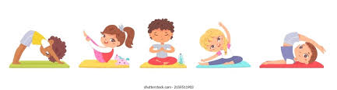

September 2024

Family Yoga Club - Year 1 & Year 2

Dear parents/carers,

Do you need to wind down after a busy day? Why not join us for family yoga? Year 1 and 2 children are invited to bring a parent, grandparent or sibling for a relaxing, after school yoga class.

This club will run 3.15-4.00pm on Wednesdays, starting from **Wednesday 25th September** until **23rd October.** Children in year 1 will already be in their PE kit, as Wednesday is one of their P.E days and will not need to bring any extra clothing or footwear. Year 2 children may wish to bring their PE kit to change in to. If your year 1 or 2 child is wanting to attend Family Yoga, but you can’t, they are welcome to come without a parent. Siblings are welcome too if parents are joining.

Places are limited, please discuss this club with your child and return the slip below if you are interested. Please note you will **be informed via text message if you and your child have a place**.

Yours sincerely,

Mr. B Linsel

Curriculum Leader of PE and Sport

…………………………………………………………………………………………………………………………………………………………….

F.A.O Office

**Year 1 & 2 - Family Yoga Club**

I would like my child ………………………………………………….................Class………………….to attend Family Yoga, starting on

**Wednesday 25th September** until **23rd October 2024**

No. of adults attending with child………………. Additional children attending………………..

Parents signature………………………………………………………………………………………………………………………………